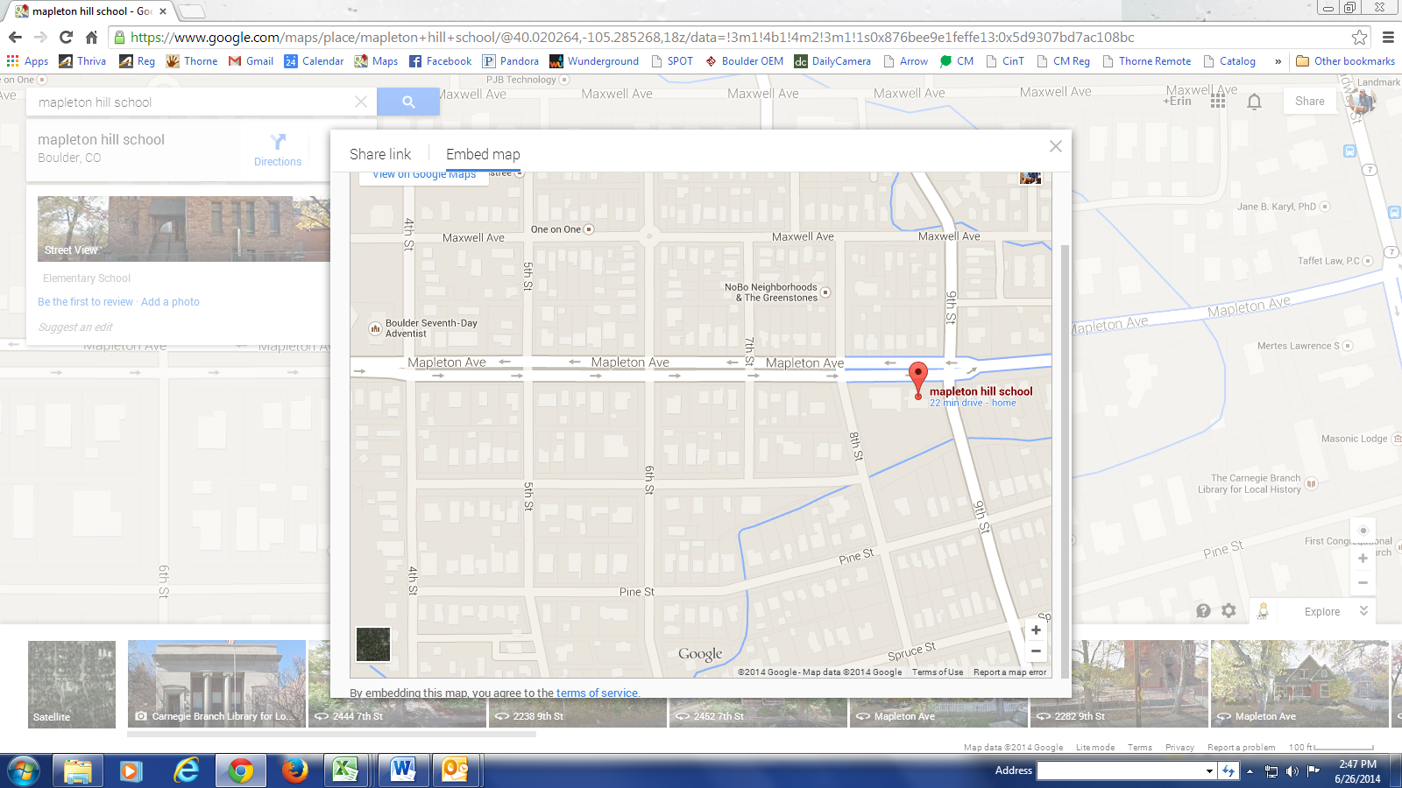

**Bus Parking**

Highland Ave

Pine Ave

**All Day Parking (Staff and TA’s and Parents)**

**Reserved Thorne Parking –**

**17 spots (PARENTS)**

**All Day Parking - Limited**

**(PARENTS and Staff)**

Mapleton Ave

8th St

**3-Hour Parking**

**(PARENTS)**

6th St

7th St